Case Study: University Student Support & Volunteer Platform
The University Student Support & Volunteer Platform is a system designed to facilitate peer-to-peer support among university students. The platform enables students to request assistance in areas such as academic support, technology assistance, new student guidance, student activities and other non-sensitive support services. Students can also register as volunteers by indicating their skills, interests and availability.
The system provides secure user registration and login with two-factor authentication (2FA) to protect student accounts. Students can create and manage their profiles, register as volunteers, specify their areas of expertise and availability, search for suitable volunteers, submit and track support requests, and communicate arrangements for support sessions. Volunteers can view incoming requests, accept or reject requests, manage their availability, and update the status of completed support activities. Students can also schedule, reschedule or cancel sessions and provide feedback following a completed support session.
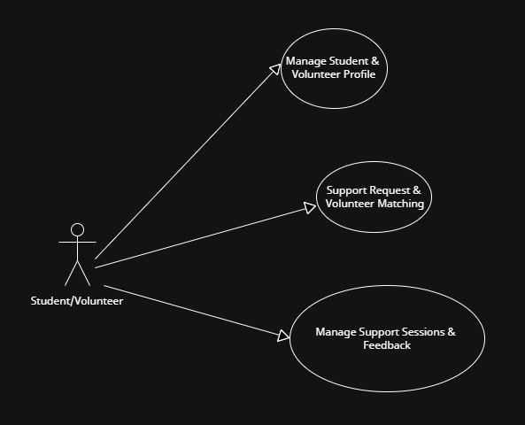
Fig. 1: UniHELP Use Case Diagram
2.0 HIGH LEVEL USE CASES

Use Case 1: Manage Student & Volunteer Profile

The student registers and securely accesses the platform using two-factor authentication (2FA). The students can manage their profile and, if they wish to volunteer, provide their skills, interests and availability.

Includes: Register account, login with 2FA, manage profile, become volunteer, manage skills/interests, manage availability.

Use Case 2: Support Request & Volunteer Matching
- The student creates and submits a support request by specifying the required assistance, preferred time and support mode, then searches for and selects a suitable volunteer. The volunteer reviews the request and accepts or rejects it, while the system records the request status and notifies the student.
- Includes: Create support request, specify support preferences, search/match volunteer, submit request, review request, accept/reject request, view request status.

Use Case 3: Manage Support Sessions & Feedback
- Once a support request is accepted, the student and volunteer arrange a session. They can schedule, or cancel the session. After completion, the volunteer records the session as completed and the student provides feedback.
- Includes: Schedule session, view sessions, cancel, mark completed, provide feedback, view support history.

3.0 EXPANDED USE CASES

Use Case 1 | Manage Student & Volunteer Profile
Goal in Context | This use case describes how a university student registers for the platform, securely accesses the system using 2FA, manages their student profile and optionally registers as a volunteer.
Primary Actor | Student
Pre-Condition | The user is not registered in the system.
Trigger | Student wants to create an account and access the platform
Typical Course of Events
Actor Action |  | System Response
- Student navigates to the registration page. |  | - The registration form is displayed.
- Student inputs required registration details: student ID, name, university email address (login name). |  | - The system validates the registration details and checks whether the student account already exists
- Student submits the registration form. |  | - The system creates the student account and sends a 6-digit verification code to the registered email address.
- Upon clicking the link,- the user enters the verification code and sets the new password |  | - System activates the account and is redirected to the student’s dashboard
Alternative Course of Events
Line 3a: If the username/email had been registered, the system will display a message informing the student that an account already exists.
Line 3b: If student selects "Become a Volunteer". Student selects one or more volunteer categories: Academic, Technology, New Student, General Student. Student specifies skills, availability and preferred support mode [Virtual/F2F].
Line 7: If the entered verification code is invalid or expired, the system prompts the user to request a new code.

Category | Examples of Support
Academic Support | Mathematics, programming, study techniques, assignment guidance
Technology Support | Software installation, basic computer support, productivity tools
New Student Support | Campus orientation, navigating university facilities, student life guidance
General Student Support | General non-academic assistance and peer guidance

Use Case 2 | Support Request & Volunteer Matching
Goal in Context | This use case describes how a student creates a support request, searches for a suitable volunteer, submits the request, and how the volunteer reviews and responds to the request.
Primary Actor | Student
Secondary Actor | Volunteer
Pre-Condition | Student must be authenticated and authenticated using 2FA and logged into the system.
Trigger | Student requires peer support.
Typical Course of Events
Actor Action |  | System Response
- Student selects "Request Support". |  | - The system displays the support request form
- Student selects a support category and describes the assistance required |  | - The system validates the request details.
- Student specifies preferred day, time and support mode. Student applies filters such as skill, availability or support mode. |  | - The system displays matching volunteer profiles.
- Student selects and submits the support request. |  | - The system records the request and notifies the selected volunteer.
- Volunteer logs into the system and able to see the notification and views the incoming request |  | - The system displays the request details.
- Volunteer reviews the request and accepts/rejects it |  | - The system changes the request status to "Accepted/Rejected" and notifies the student.
- Student views the request status. |  | - The system displays the updated request status.
Alternative Course of Events
5a. If no volunteers match the selected criteria, the system informs the student and allows them to modify the search criteria.
6a. If the selected volunteer is no longer available, the system informs the student and allows them to select another volunteer.
12a. If the volunteer does not respond within the specified period, the system maintains the request as "Pending" and allows the student to select another volunteer.

Use Case 3 | Manage Support Session and Provide Feedback
Goal in Context | This use case describes how a student and volunteer schedule and manage a support session, record its completion, and provide feedback after the session
Primary Actor | Student
Secondary Actor | Volunteer
Pre-condition | A support request has been accepted by a volunteer.
Trigger | The accepted support request requires a support session to be scheduled.
Typical Course of Events
Actor |  | System Response
- Student or volunteer selects "Schedule Session". |  | - The system displays the available dates and times based on the volunteer's availability.
- Student and volunteer agree on a date, time and support mode. |  | - The system checks the selected slot and displays the session details.
- Student or volunteer confirms the session. |  | - The system creates the session and changes the request status to "Scheduled"  The system displays the session date, time, support mode and participant details to both student/volunteer.
- Volunteer selects "Mark Session as Completed" once session is completed. |  | - The system changes the session status to "Completed" and enables the feedback function.
- Student provides a rating and optional comments. |  | - The system validates and saves the feedback against the completed session and volunteer.
- Student or volunteer views their support history. |  | - The system displays previous support requests, sessions and feedback.
Alternative Course of Events
7a. If the student or volunteer cancels the session, the system changes the status to "Cancelled" and notifies the other participant.
9a. If the student attempts to provide feedback before the session is completed, the system prevents submission and displays a message.

